**6.Generate Flight login script by using Step Generator:**

Before going to Generate Script open flight application

Start🡪All programs🡪Quick test professional🡪Sample application🡪Flight

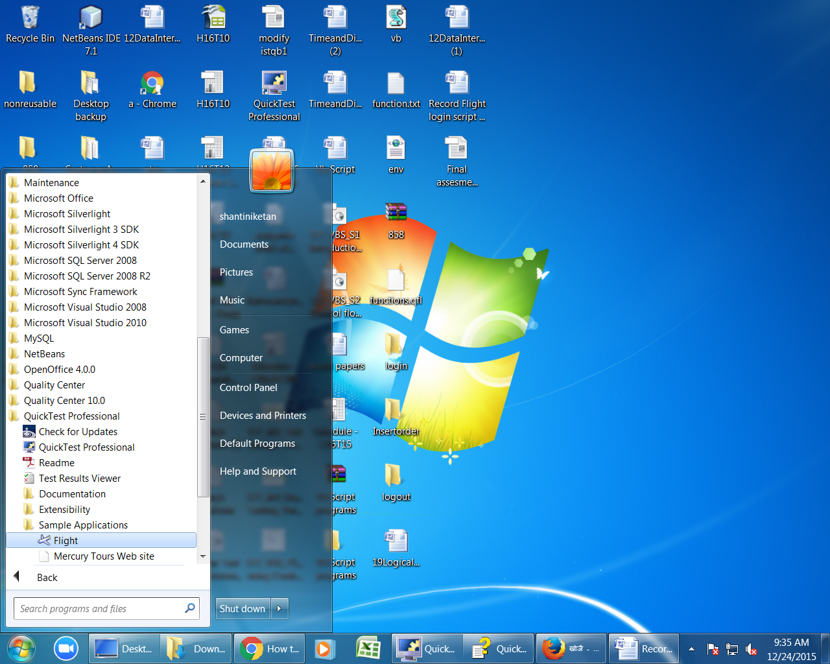

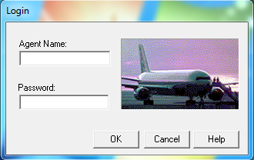

Open quick test Start🡪All programs🡪Quick test professional🡪

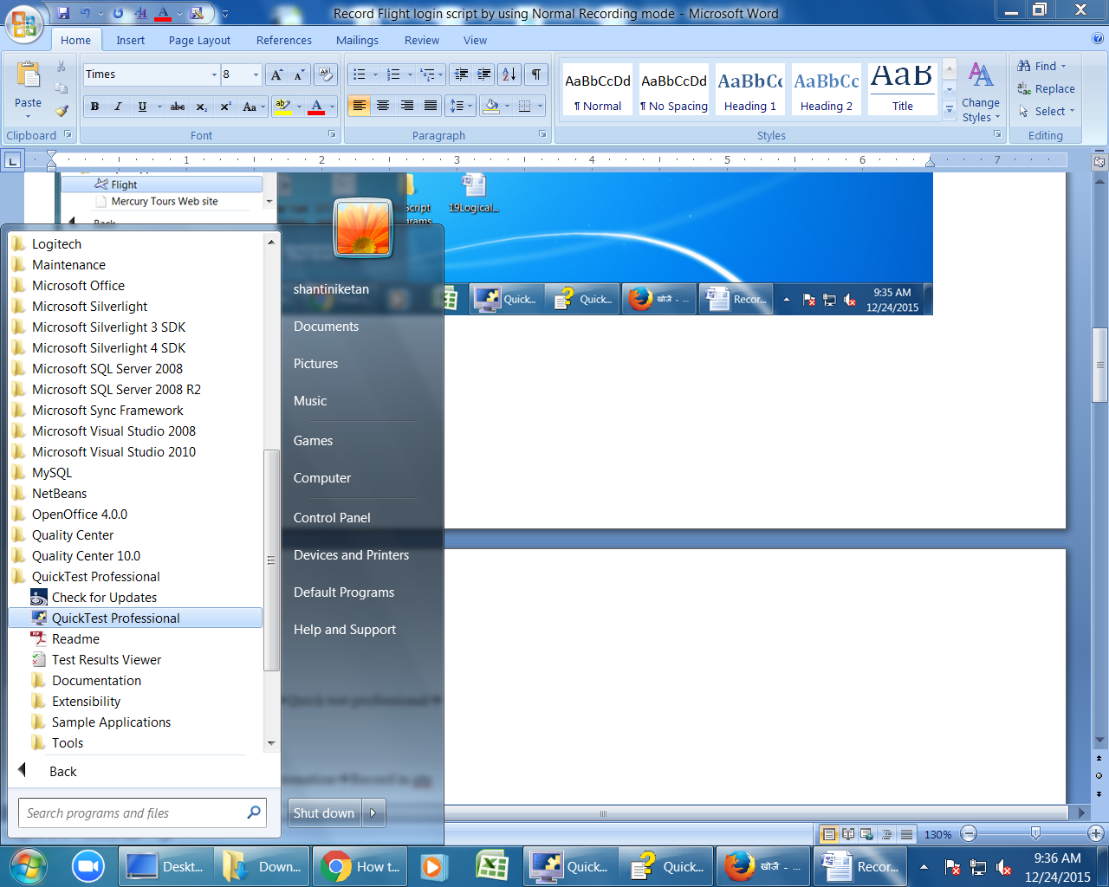

Qtp widow open like below

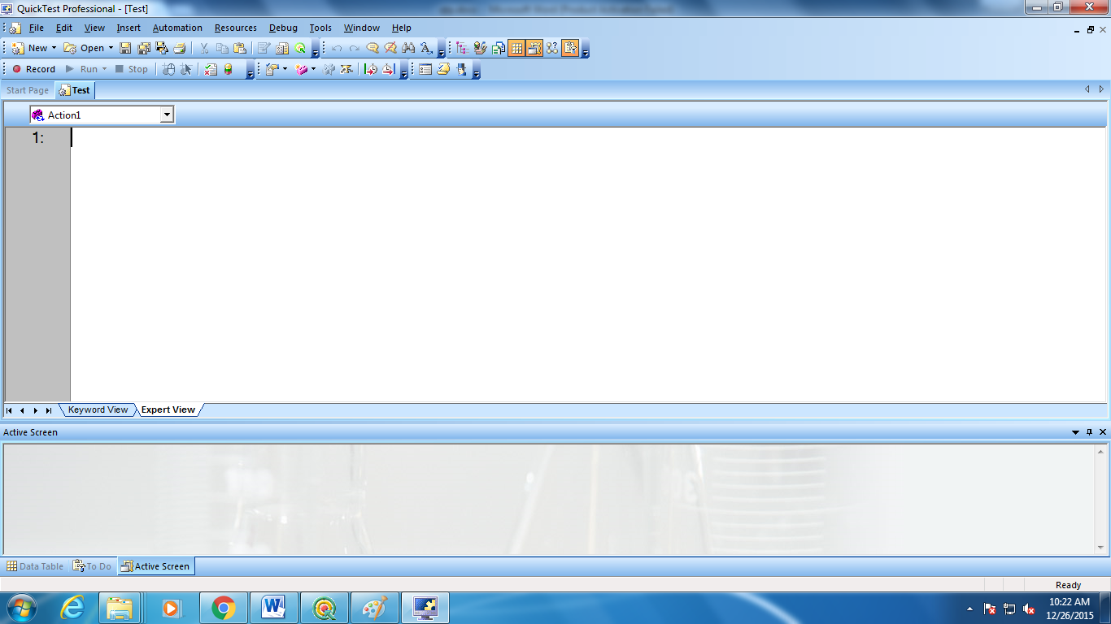

Select Insert🡪StepGenerator/F7, It opens Step Generator Window

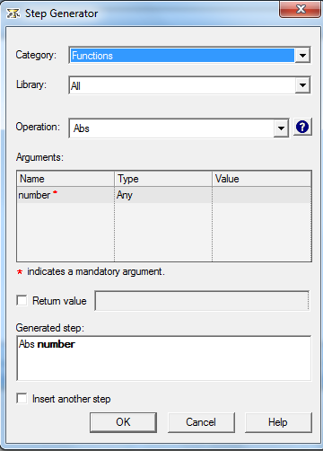

Select Test Objects option in Category list box.

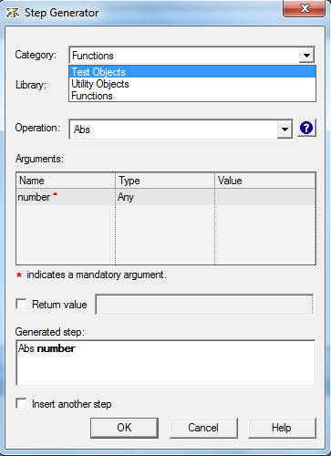

Click on “select Object “ button

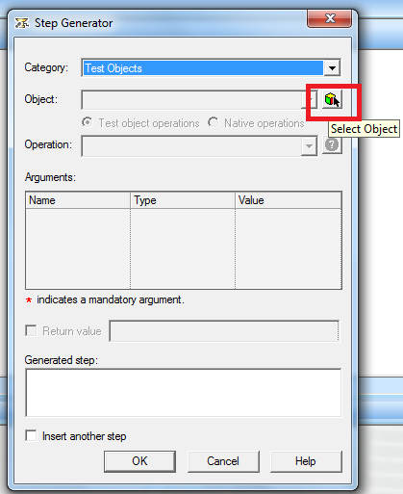

Click on “Hand Icon” button

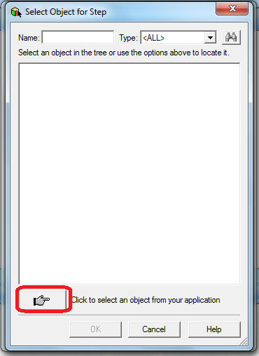

qtp minimized and filght login window will be enabled.

Select Agent name text box in flight login window

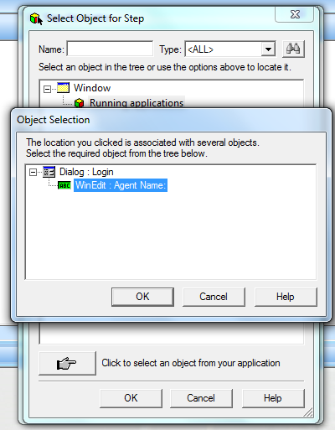

Click on ok button in object selection window

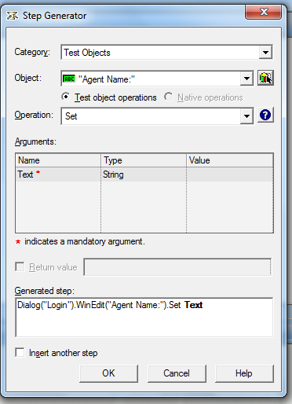

Enter input value as Ramesh in Value column

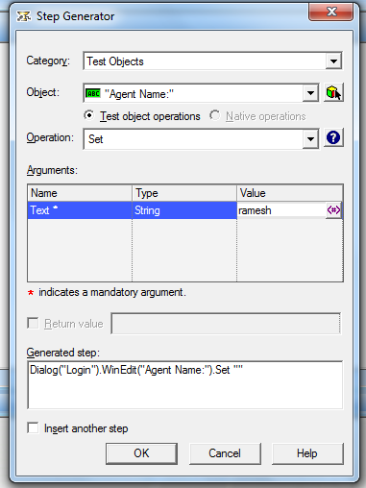

Click on “ok” then script will be generated in expertveiw in qtp. Like this we can generate all the steps for all functionalities in an application

